**SPRINT - IV**

|  |  |
| --- | --- |
| ***Date*** | ***16.11.2022*** |
| ***Team ID*** | ***PNT2022TMID16797*** |
| ***Project Name*** | ***Smart Farmer - IoT Enabled Smart Farming Application*** |

**Creating a MIT app inventor account:**

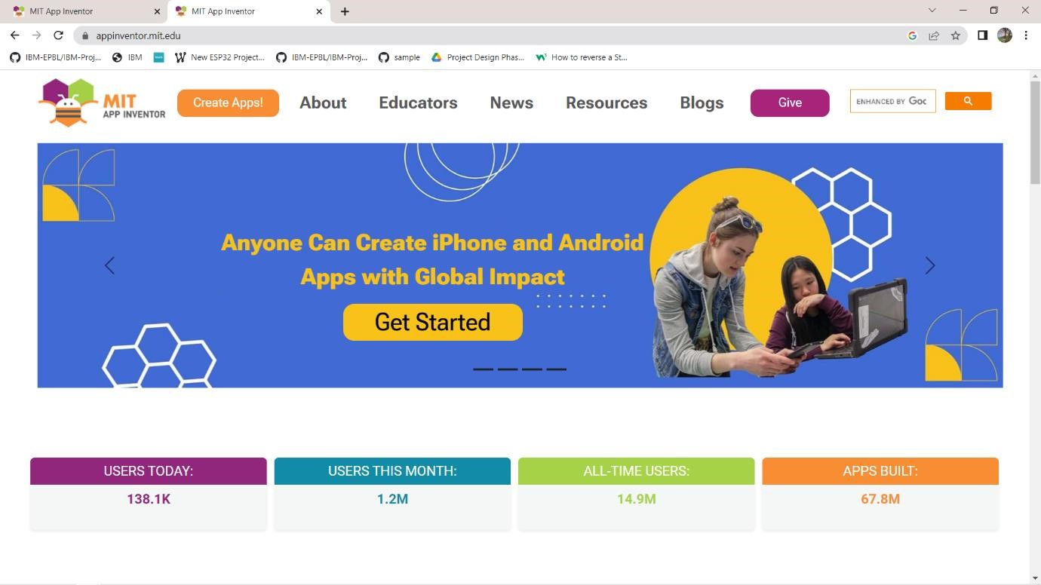

**Designing the user interface:**

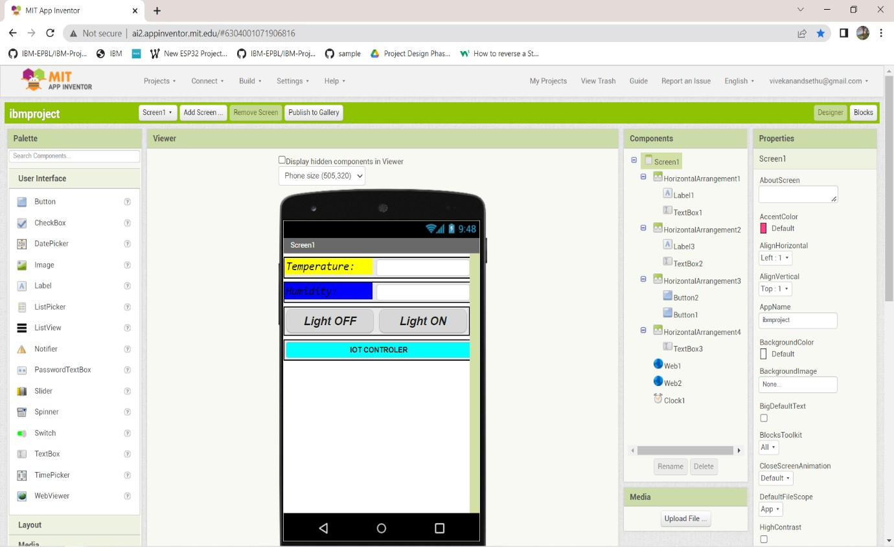

Connecting the circuit Blocks :

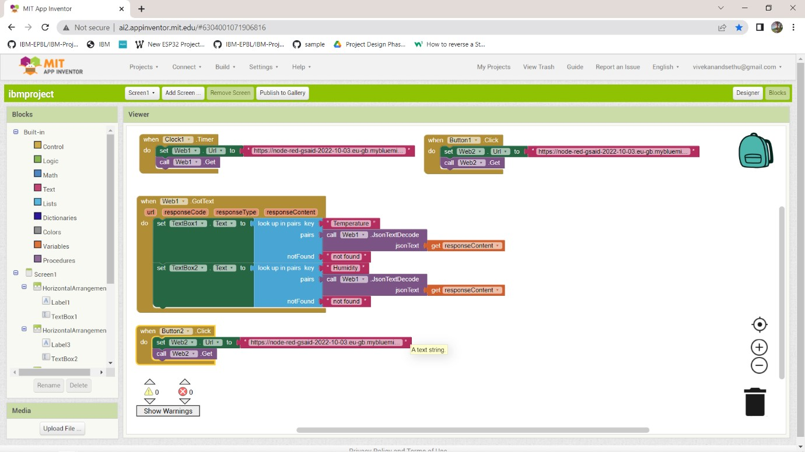

Entering the response content:

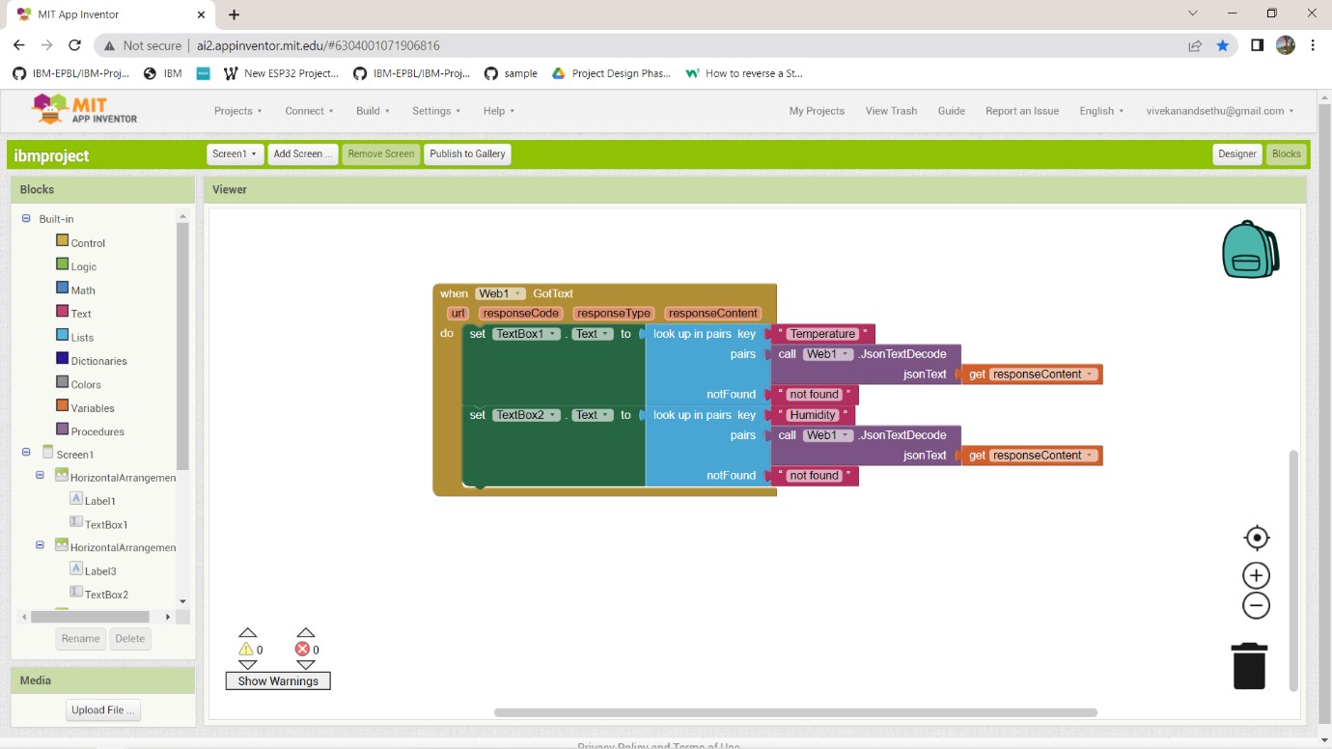

Entering the data fetching Node-red url:

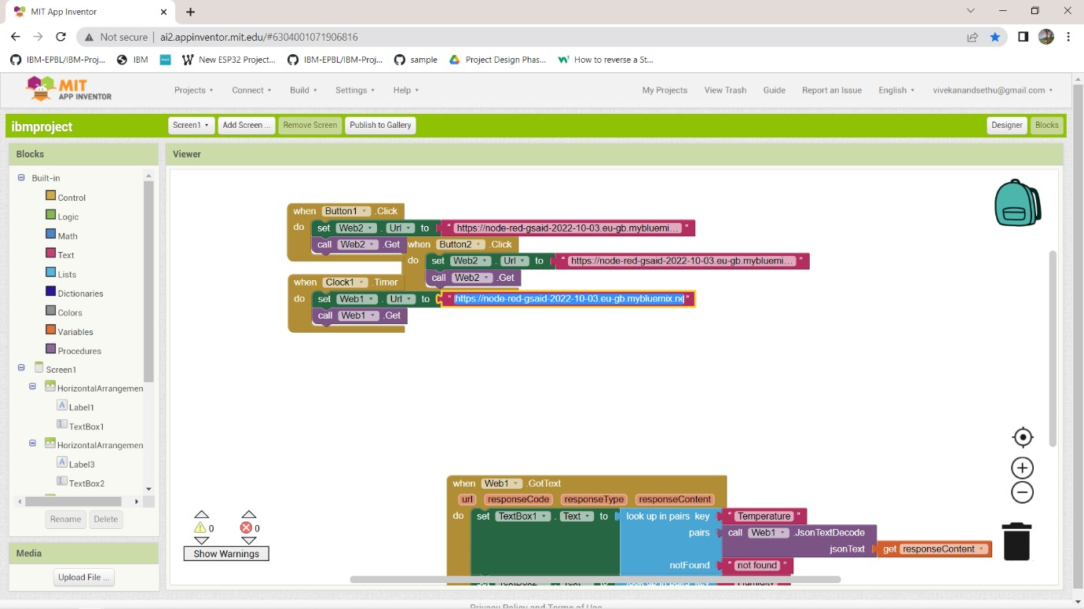

Connecting with the mobile companion:

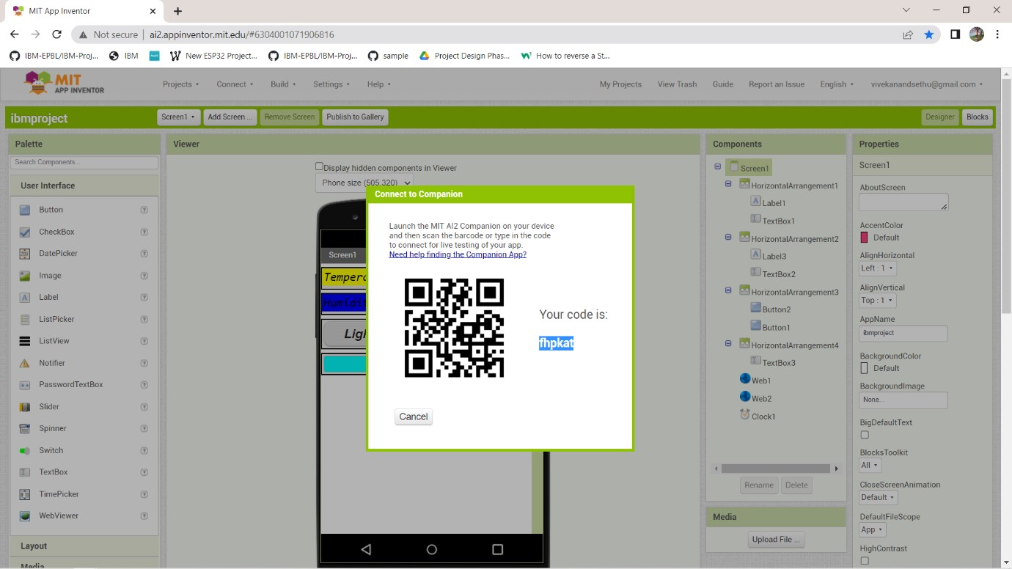

Scan the QR code or enter the code displayed on the screen on the MIT mobile app companion, after installing it.

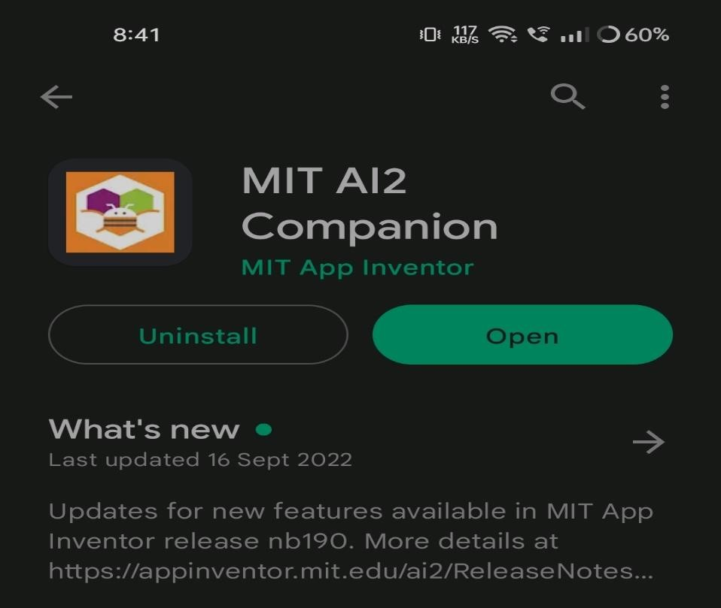

Deploying it as app:

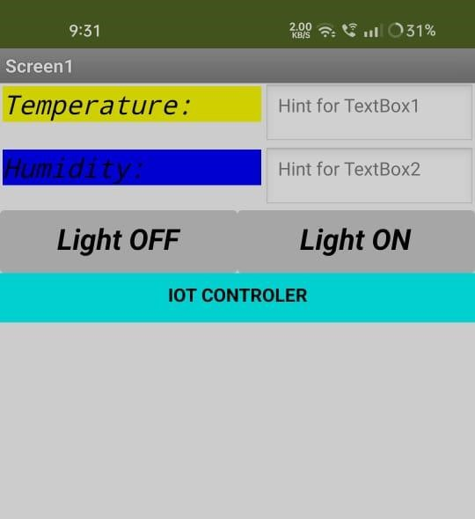

Receiving data from the cloud in the app:

